Composed Drawings
Composed Drawings can be created using a combination of commands available in the 3D tasks, the Drawings and Reports task and the 2D Drawing Editor. They can be created in the 3D Tasks, manage them in the Drawings and Reports task, and modify the templates and the drawing layout in the 2D Drawing Editor.
Composed Drawings can be created using Drawing Volumes, Space Volumes and Snapshots.

1-Volume Workflow

Creating the Component and Drawing
COMPONENT DEFINITION
- In Drawings and Reports, right mouse click on the ortho drawings folder for your discipline (i.e. Electrical) under the Plant and select New…
- In the Add Component Dialog, from the General tab, select “Composed Drawings”
- Rename the newly created drawing type to “Training Composed Drawings”
DRAWING DEFINITION
- Change to Space Management task by selecting Tasks > Space Management from the menu bar of your current SP3D environment.
- For future use, create a volume folder for your discipline at this time (for these labs, create at least one Electrical and one Structural), then revise your workspace (Ctl+W) to include your volume folders in the Named Space filter properties tab.
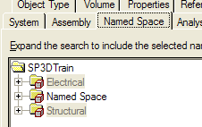
- To facilitate creation of views from a volume, use the “Place Drawing Volume by Four Points” command to define a drawing by volume. We won’t need the drawing but will use the volume. This will help illustrate how you may reuse volumes previously created to extract Volume Drawings. Place the volume over any desired drawing area of your model for this exercise. As a minimum define a volume with some structural and some cable tray in it
- In the Space Management task, select Tools > New Drawing.
- For the “Location” property, drop down the select list and choose “More”. In the “Select Drawings Component” dialog select your discipline ortho drawings folder and click on “Training Composed Drawings” created a moment ago.
- For the “Name” property, type in “Composed Drawings Lab1”. This will be the name of the physical drawing created in the component created above.
- For the “Layout Template” property, drop down the select list and choose “More”. In the “Select Template”, select the Empty.sha template or a Shaw-specific template and click OK.
- For the “Border Template” property, drop down the select list and choose “More”. In the “Select Template” dialog, navigate to the Shaw E-size template for your discipline, if none available, double click the “Imperial” folder. Select the Intergraph D_Wide.sha template and click OK.
- Click OK on the “Drawing Sheet General Properties” dialog, which will open the Shape2D drawing editor behind SP3D. Bring the Shape2D drawing editor up as the active application.

B. Placing the Views

- In Shape2d, fit the view and select the “Place Region” command
- Use single-clicks to place the region corners such that you get a box taking up about half of the drawing space inside the border
- In the Region Properties box enter name and description, for the Layout Style select “Two View A” and OK. Your drawing should look something like this:
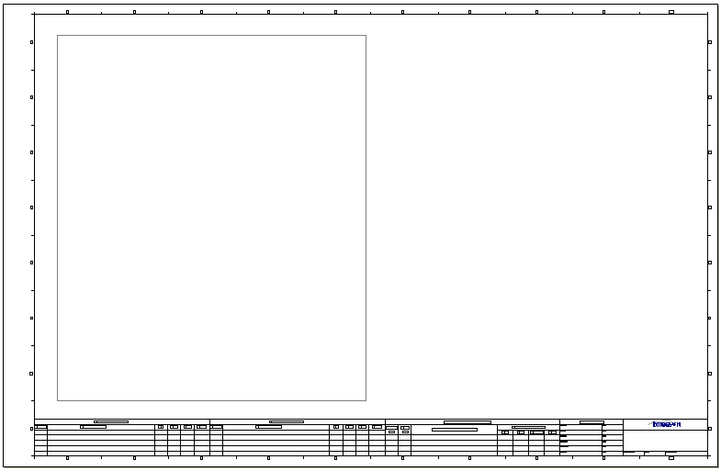
- Select “Place View” command from the horizontal toolbar.
- With this command active, place a view anywhere inside the region frame using a two point method.
- After the view is placed the “Drawing View Properties” dialog will display. On the View tab of this dialog, drop down the “Style” select list and choose “More”. This will open the “Select View Style” dialog. In the Orthographic folder, select an Elevation style for your discipline, i.e. “Electrical Cable Tray Elevation” and click OK.
- Notice, after the view style is selected, more options appear for the definition of this view. It will look as follows:
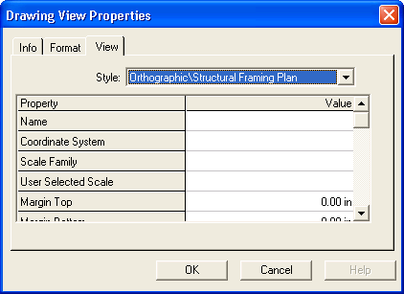
- For the “Name” property, type in “North1”.
- For the coordinate systems, choose “Global CS” or another suitable coordinate system to measure coordinate locations in this drawing
- For the “Scale Family” property, drop down the select list and choose “Architectural Scales” and set the “..Selected Scale” to 1/8in=1ft
- Scroll down in this dialog and locate the property “Look Direction”. This field should be set to “Looking North”
- In the Format tab un-check the “Show Border” box and select OK
- Once this dialog is closed the drawing template will automatically save the changes made to the template up to this point. Notice that the view is saved and automatically fitted to the bottom half of the Region
- Place another view of random size within the upper half of the Region.
- Pick a Plan view style for this view according to your discipline, i.e. “Electrical Cable Tray Layout Plan”
- Name this view “Plan1”, set the coordinates and scale information same as you did for the Elevation view. Make sure the “Look Direction” is “Looking Plan”
- In the Format tab un-check the “Show Border” box and select OK
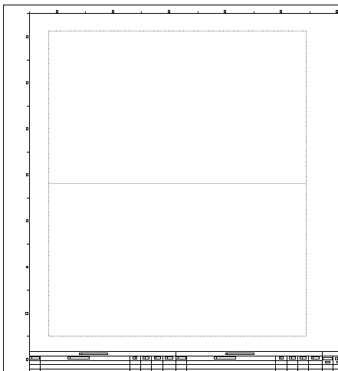
- Select “Place View” command and place a third view completely outside the region on the right side of the drawing area. This is called an “Unmanaged” view because it doesn’t have an association to any regions on the drawing.
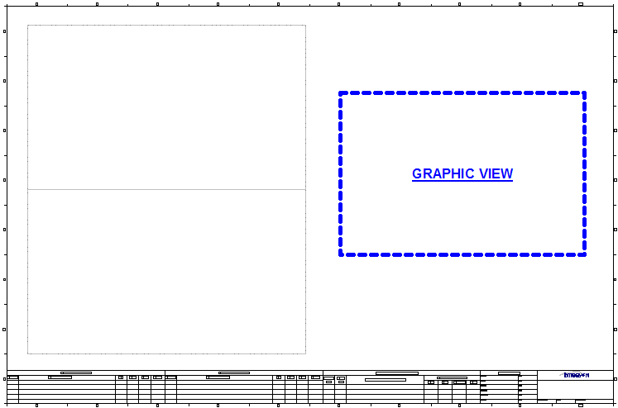
- In the Orthographic style folder select a View Style for Isometrics in your discipline, i.e. Electrical Cable Tray Isometric
- Enter view property info and scale as before, make sure to set “Look Direction” to “Looking NorthEast Down”
- In the Format tab un-check the “Show Border” box and select OK

C. Associating the Volumes to Views
- After placing the views, the volume(s) will need to be associated to them. Choose the first view placed (View1), by clicking on the border of the view, and select the “Associate Objects to View” command located on the horizontal toolbar.
- With this command active, go back to SP3D, which should be open behind the Shape2D drawing editor and notice the ribbon bar in SP3D. The ribbon bar should look as follows:
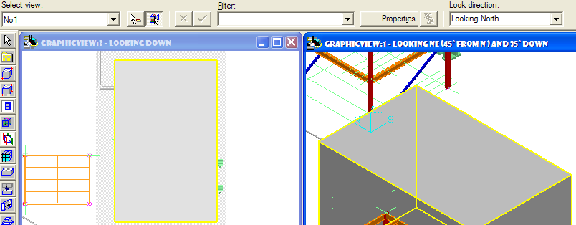
- Notice that the View name and looking direction are the presets from the view definition in the drawing editor (shape2d)
- Select the volume created earlier in this lab as part of a volume drawing. The volume will be highlighted. With this volume selected, switch back to Shape2D and click the “Save” button. This has associated this volume with the view selected in Shape2D.
- Choose the second view created earlier in Shape2D by clicking on the border of the view, and select the “Associate Objects to View” command located on the horizontal toolbar
- For this view, select the same volume used earlier. This allows users to look at the same volume from multiple directions in a drawing
- With this volume selected, switch back to Shape2D and click the “Save” button. This has associated this volume with the view selected in Shape2D.
- Repeat this procedure one more time to associate the iso (third) view with the same 3D volume and save your drawing in Shape2D.
- Close the Shape2D application.

D. Updating the Drawing
- Change to the Drawings and Reports task by selecting Tasks > Drawings and Reports from the menu bar of your current SP3D environment.
- Navigate to the new component created in your discipline’s orthos folder in the Management Console and select it. In our earlier example for this exercise we created a component named “Training Composed Drawings” where we placed the training drawing.
- Notice the drawing created from this lab has the icon next to it, meaning it hasn’t yet been updated. Right mouse click on the drawing and select “Update Now”. 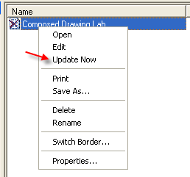
- When the drawing is Up-To-Date ( ), right click the drawing and select Edit to view/edit the results in Shape2D.
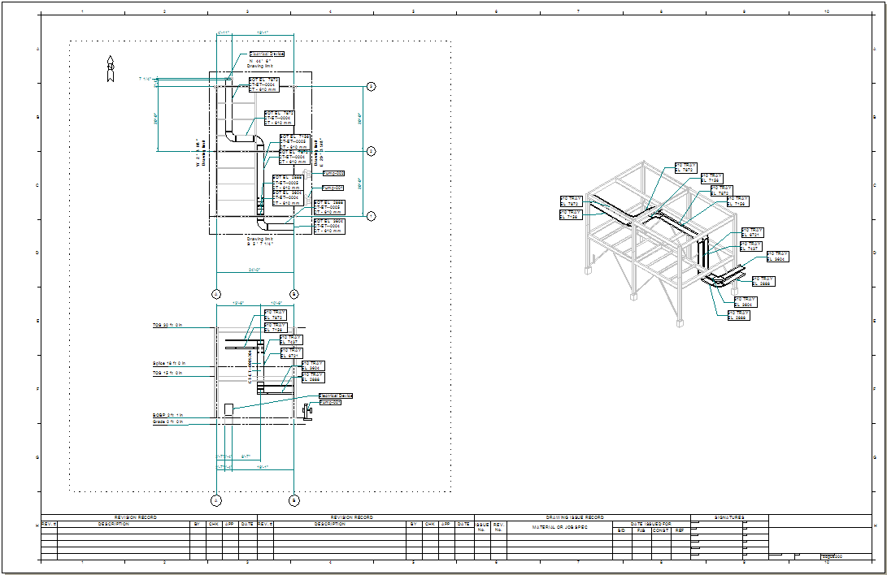

2-Snapshot Drawings Workflow

A. Creating a Compose Drawing Type
Snapshot drawings are placed on a drawing component called Composed Drawings. This component can be created in two ways.
a. Creating Drawing component in Drawings and Reports
- In Drawings and Reports, right mouse click on the ortho drawings folder for your discipline (i.e. Structural) under the Plant where you want to place the new compose drawing group and select New…
- In the Add Component Dialog, from the General tab, select “Composed Drawings”
- Rename the newly created drawing type to “Snapshot Composed Drawings”
b. Creating Drawing component in Modeling Task
- Go into the Common Task by selecting Task > Common from the menu bar.
- In the Common Task (or any other modeling task), select Tools > New Drawing from the menu bar. The following Dialog will appear:
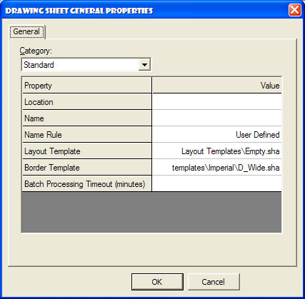
- For the Property “Location”, drop the list down in the “Value” column and select “More”. This will display the hierarchy created in the Drawings and Reports task. There are two options at this point:
  - Navigate to and select your discipline’s drawings folder, i.e. “Structural” and click OK. This will force the creation of a new composed drawing component definition with a generic name such as “New Composed Drawings (2)”. Or…
  - Navigate further down and select a Composed Drawing component previously created in the Drawings and Reports task, for this example we created “Snapshot Composed Drawings”. For this example you’ll pick this option
- For the property “Name” type in “Snapshot”. This field will define the name of the drawing in the Drawings and Reports task.
- For the property “Layout Template”, drop the list down in the “Value” column and select “More”. Navigate to and select a Shaw template if available, otherwise pick delivered template “Empty.sha”.
- For the property “Border Template”, drop the list down in the “Value” column and select “More”. Navigate to and select a Shaw border template for your discipline if available, otherwise pick a delivered one in the “Select Template” dialog, double click the Imperial folder, which will extend the list, select the D_Wide.sha as the border template.
- Leave Batch timeout setting blank and click OK
- This will open the Shape2D drawing editor application, containing the template chosen in the previous step, allowing you to place views. Since we have no Snapshot views to place on the template, we must create these views in SP3D.
Leaving the Shape2D application open behind SP3D, proceed to the next lab.

B. Snapshot the views
  - While in the Common task (or any modeling task), redefine the workspace to be a volume tight around your target graphics like the example below (Hint: Use Clip by Object or Clip by Volume command)
Before: 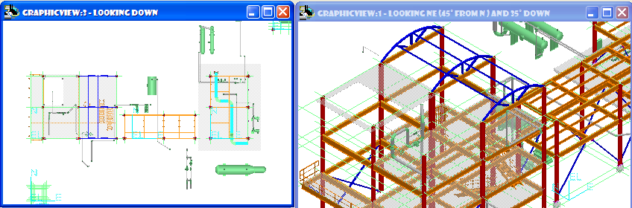
After:
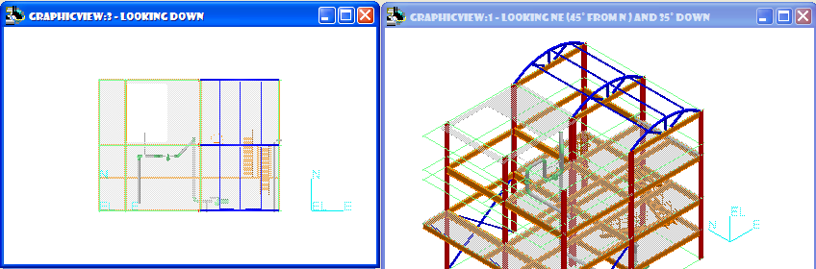
  - Set the 3D view orientation to Plan and fit the graphic view.
  - Select Tools > Snapshot View. Once this command is active, you will be presented with the following ribbon bar:
  - For the “Drawing type” field, drop down the select list and choose “More”. This will open the Hierarchy in Drawings and Reports. Navigate to your discipline drawings folder and select “Snapshot Composed Drawings”. Click OK.
  - For the “View name” field, type in “FramingPlan”.
  - By typing in the View name, the next field, “Naming rule”, will default to “User Defined”.
  - For the “View Style” field, drop down the select list and choose “More”. This will open the dialog “Select View Style”. Select a Shaw framing plan view style under the “Orthographic” folder, if none available use the “Structural Framing Plan” view style delivered with the product and click OK.
  - For the “Space Folder” field, drop down the select list and choose “More”. The “Select Space Folder” dialog will open. Navigate to select your “Structural” space folder (created and added to your workspace earlier in this manual) and click OK.
NOTE: This defines where, on the Workspace Explorer Space tab, this view will be stored for future use.
  - Once these fields have been populated, click the “Finish” button on the far left of the ribbon bar.
  - Set or select a 3D view with orientation to Iso and fit the view
  - Snapshot this view as done above, name it “IsoNE”, be sure to use a framing isometric view style.

C. Composing the drawing
- Set the Shape2D drawing editor application as the active window on the desktop.
- In Shape2D, select the “Place Snapshot View” button located on the toolbar. This will activate a new ribbon bar as follows:
- For the “View Name” field, drop down the select list and notice that only the two views that were created in the previous lab are displayed. Select the view named “FraminPlan” for this field.
- For the “View Style” field, the style defined while placing the view is remembered and will be the style used. In this case, we are using a framing plan view style.
- For the “View Scale” field, the “Fit to Scale” option is defaulted. To view the available scale families, simply drop down the select list and pick “Architectural Scales”
- From the next pulldown select scale 1/4in:1ft
- Once these fields are populated, place the view in the drawing frame. View will appear attached to your cursor over the drawing area.
- Similarly place the IsoNE view on the same drawing. If needed, select a different scale to make it fit inside the border
- Once these views are placed, the document will automatically save. Exit the Shape2D drawing editor application.

D. Updating the documents
- Go into the Drawings and Reports task by selecting Tasks > Drawings and Reports.
- Expand your structural drawings folder from the lab above and click on the “Snapshot Composed Drawings” component in the Management Console. Notice, under this component, the drawing “Snapshot” created in the previous lab.
- Right click on the drawing “Snapshot”, and select “Update Now”.
- After about 1-2 minutes the drawing is updated. Right click on the drawing “Snapshot” and select Edit to view the output of the drawing.

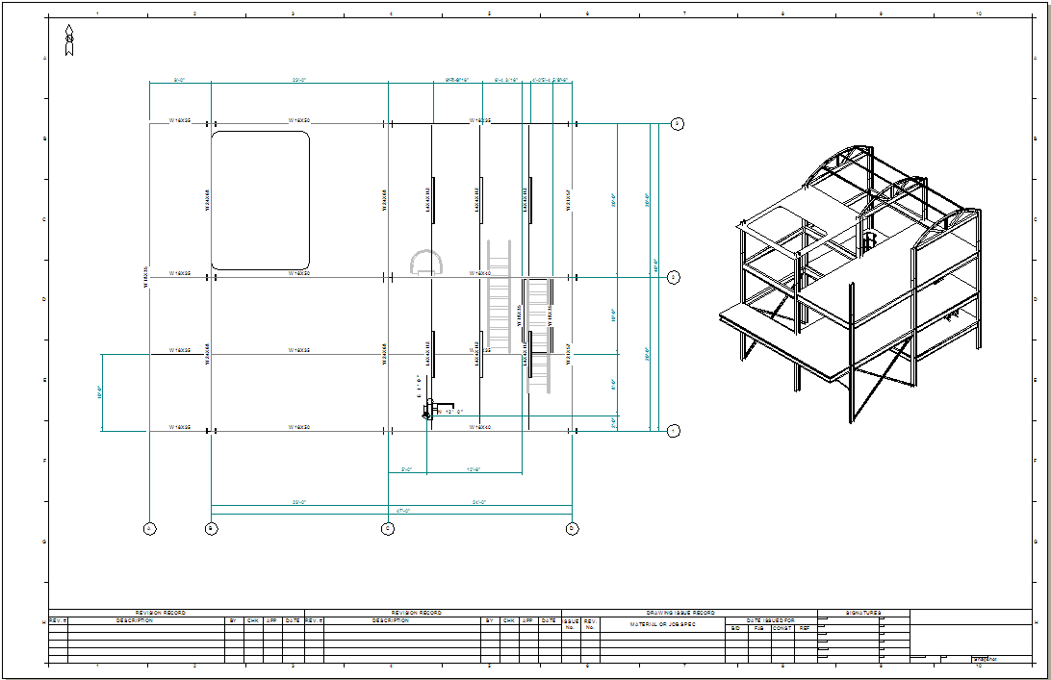

3-Layout Drawing using Volume by Object

A. Creating a Volume by Object

- Go into the Space Management task by selecting Tasks > Space Management
- Select the Create Space Folder command
- Enter “Equipment” for the folder name
- The parent should be the plant root level, in this case “SP3DTrain”
- Select Finish
- On the Workspace Explorer select the Space tab, it should show the new space folder
- Select the Place Volume By Selectset command
- In the ribbon bar, name the volume ALLEQP
- Set the space Type to: more…>Definitions>Drawing Volumes>DWGVOLUME1 and OK
- Set the Space folder to: more…>SP3DTrain>Equipment
- Select the outermost graphics that will define the size of the volume, for example, the highlighted items shown were selected to define this volume:
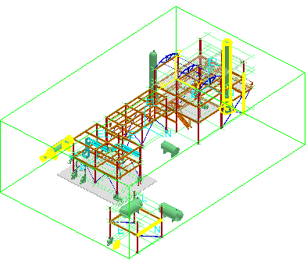
- Select Finish. The volume becomes a solid. Optionally, use Format>Style command to make the solid translucid

B. Creating the Drawing Definition

- Switch to the Drawings and Reports task
- If needed, right click on SP3DTrain and select “New…” to create a new folder named ORTHOS
- Right click on ORTHOS and select New>Composed Drawings and OK
- Rename the new component to EQP_LOCATION
- Switch task to Space Management
- In space management, select Tools>New Drawing…
- Define the drawing properties as follows and OK:
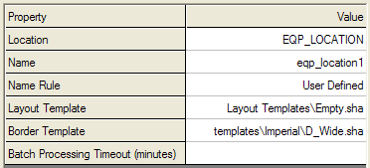
- The 2D Drawing Editor should appear. Maximize the viewing window which should just have the border at this point
- Select the Place View command
- Define the view end points across most of the drawing area
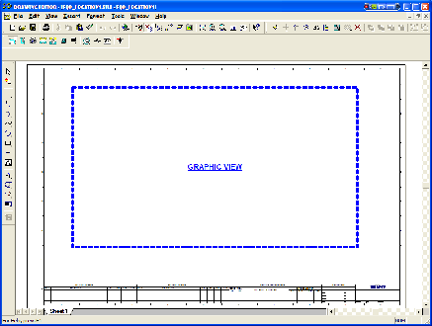
- Set the style for this view to Orthographic>Equipment Plan
- Set the view properties as follows (looking direction defaults to “Plan”):
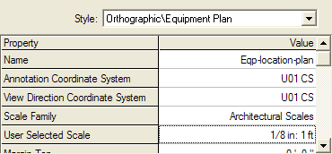
- Turn off “show border” under the Format tab and OK
- Select the view border and select Associate Object to View command
- Bring the 3D interface to the front
- Select the volume “ALLEQP”, it will highlight in yellow
- Return to the 2D editor
- Select the Save command and exit 2D editor
- Switch Tasks to Drawings and Reports
- Find Drawing “eqp_location1” under EQP_LOCATION component
- Right click on the drawing and select Update Now
- If update is successful (green check on dwg name), right click and select Edit to review the drawing, e.g.:
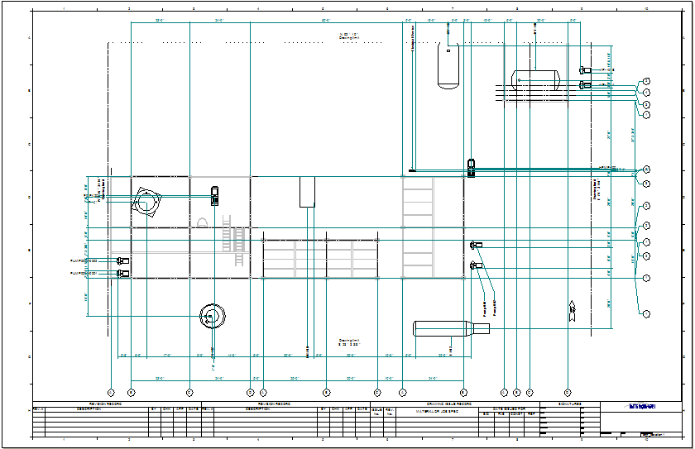

C. Entering Title block Data

- Switch to the Drawings and Reports task
- Right click drawing “eqp_location1” and select Properties…
- Select the Title Area tab
- Set Title1 to EQUIPMENT LOCATION and Title2 to N-FLOOR
- Select the Signature Area tab
- Enter Designed By and Date information
- Enter Checked By and Date information
- Select Revision tab and enter rev 0 - IFC info and OK form
- Notice the X on the drawing. Right click and Update Now to reprocess the drawing
- Open the drawing in the 2D Editor and review the title block area to look for your updates, e.g.:
